# **ML | Classification vs Regression**

Classification and Regression are two major prediction problems that are usually dealt with in Data mining and machine learning.

**Classification** is the process of finding or discovering a model or function which helps in separating the data into multiple categorical classes i.e. discrete values. In classification, data is categorized under different labels according to some parameters given in input and then the labels are predicted for the data.

The derived mapping function could be demonstrated in the form of “IF-THEN” rules. The classification process deals with the problems where the data can be divided into binary or multiple discrete labels.

Let’s take an example, suppose we want to predict the possibility of the winning of a match by Team A on the basis of some parameters recorded earlier. Then there would be two labels Yes and No.

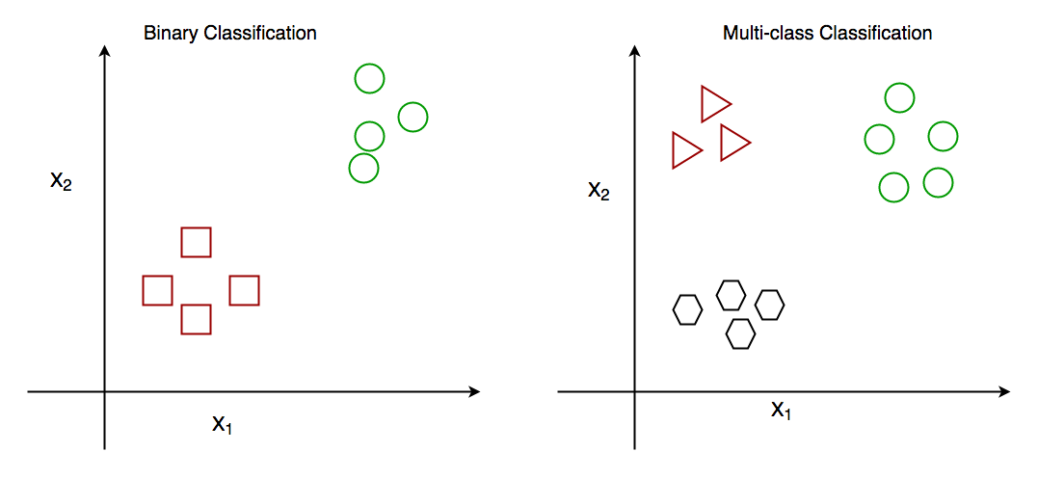

Fig: Binary Classification and Multiclass Classification

**Regression** is the process of finding a model or function for distinguishing the data into continuous real values instead of using classes or discrete values. It can also identify the distribution movement depending on the historical data. Because a regression predictive model predicts a quantity, therefore, the skill of the model must be reported as an error in those predictions

Let’s take a similar example in regression also, where we are finding the possibility of rain in some particular regions with the help of some parameters recorded earlier. Then there is a probability associated with the rain.

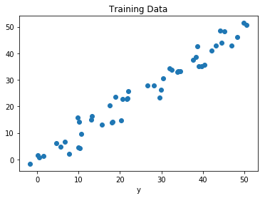

Fig: Regression of Day vs Rainfall (in mm)

**Comparison between Classification and Regression:**

| Parameter | CLASSIFICATION | REGRESSION |
| --- | --- | --- |
| Basic | The mapping function is used for mapping values to predefined classes. | Mapping Function is used for the mapping of values to continuous output. |
| Involves prediction of | Discrete values | Continuous values |
| Nature of the predicted data | Unordered | Ordered |
| Method of calculation | by measuring accuracy | by measurement of root mean square error |
| Example Algorithms | Decision tree, logistic regression, etc. | Regression tree (Random forest), Linear regression, etc. |